Smtp Mail Sender

Contents

Requirements 3

Feature 3

How to Use 3

Advance Use 5

Known Issue 6

Warning 6

# Requirements

1. Server is must in a domain.
2. .Net Framework 4.0 required.

# Features

1. Send a large amount of mails with good performance.
2. Pickup mailboxes in domain (depends on the user you login the tool).
3. Generate mails subjects and bodies by dictionary.

# How to Use

1. Open the tool and login with a user in your domain.

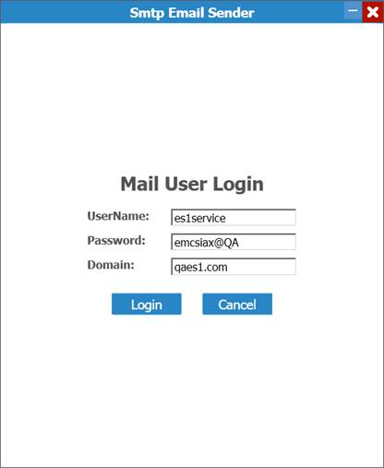

1. Fill the settings in “Sender Setting” panel.
2. Input the SMTP server name.
3. Pickup “Senders” and “Receivers” for mails.
4. Specified mail subject length and mail body length.
5. Check “Enable Attachments” and put some attachments in “Attachments Path”, if you want mails with attachments.
6. Select words dictionary in “Words Dictionary Path”.
7. Fill the number of mails you want to send in “Random Send”

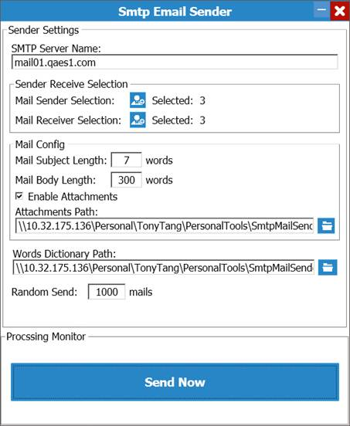

1. Click “Send Now”.

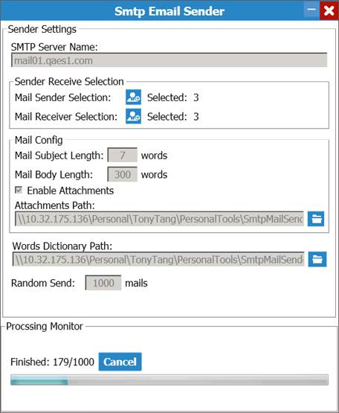

# Advance Use

1. Modify Dictionary to increase index size or other usages.

Add lines in [dictionary].txt

1. Modify App.config file(careful to change the value in this file)

Use XML editor to open “SmtpMailSender.exe.config”, show as below and edit the appSettings’ value.

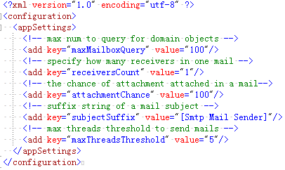

# Warning

**DO NOT** use you **corp account** to login in and **send mails**!